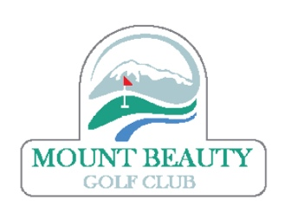
Mount Beauty Golf Club
Notice of AGM: Tuesday 17 October 2023 @ 7.00pm
To be held at the Mount Beauty Golf Club Clubrooms.

Apologies:

1. Minutes of previous meeting: Attached.

2. Tabling of Reports

3. President’s Report: To be circulated

4. Annual Financial Report: To be circulated

5. Retirement of Club Officers and half of Committee

6. Election of Club Officers and half of Committee:

Club Officer Incumbents are:

PRESIDENT Stephen Short
VICE-PRESIDENT Peter Johns
SECRETARY Michael Bartholomew
TREASURER Roger Church
CAPTAIN Peter Hertzog

All are renominating.

General Committee Incumbents are:

Dave Browning – renominating
Allan Retallick – renominating
Peter Dilley -

A Nomination Form has been attached for anyone wishing to nominate either themselves or a third party, for any position.
Please return any nominations to secretary@mtbeautygolfclub.org.au by midnight on Sunday 15 October 2023.
A Proxy Form has been attached if any member is unable to attended the meeting and wishes to have a vote via a third person who is present at the meeting. Please return any proxies to secretary@mtbeautygolfclub.org.au by midnight on Sunday 15 October 2023.

10. General Business: None

11. Notice of motions: None

If you have any business you wish to have discussed at the AGM please notify secretary@mtbeautygolfclub.org.au by midnight on Tuesday 10 October 2023.

