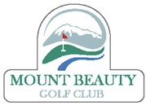

2023/2024 Nomination Form

Executive and Committee Positions

Position_________________________

Name of Nominee_________________________

Signature of Nominee_______________________

Nominated By__________________________

Signature_________________________________

Seconded By____________________________

Signature_________________________________

Completed nomination forms to be received by club no later than Tuesday 10th October 2023.
Only financial and life members of Mount Beauty Golf Club Inc. are eligible to make or accept nominations or second nominations.

Each member of the club who is present at the AGM or by proxy, has one vote.

